

Dr. Elizabeth, Pennington inc.

2020-12-09

Dr. Pennington

Unit 8121 Box 7987, DPO AE 53132

Phone: 5128114429

Fax: 4876180570

**Re:** Sara, Warren

**PHN:** 751353599

**Birthdate:** 13-Jan-1981

**Address:** 58913 Harvey Fort Apt. 334, Lake Caseystad, IA 31138

**Patient number:** 1169055916

To Whom It May Concern:

This is a medical letter to state the above patient is pregnant with expected delivery date of 11-Oct-2025. Hoping this information is satisfactory for your requirements.

Thank you.

Sincerely,

Dr. Elizabeth, Pennington

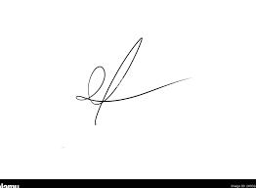

FRCS© NCMP

Clinical Assistant Professor, UBC

Department of Obstetrics and Gynecology SMH